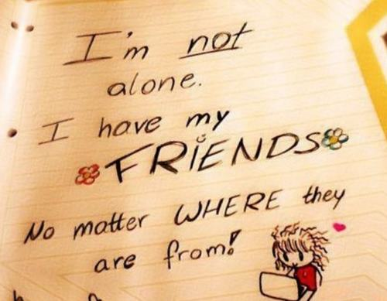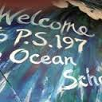1

**Reading - Into-Reading**

The fifth grade will begin working on Tackling Complexity: Moving Up Levels of Nonfiction. Students will be identifying text features and text structures in nonfiction texts. In writing, students will be writing a research report on the Western Hemisphere. Students will be immersed in reading and writing nonfiction texts. Please have students read in their “just right books” or online whenever possible.

**Writing**

Our writers are now ending their personal narratives using our TC writing curriculum. Publishing parties will begin soon. Due to the pandemic, we are not able to invite parents up to the classrooms for our publishing parties. More news on how publishing parties will be conducted is forthcoming.

**Math**

Our mathematicians are working on Adding, Subtracting, Multiplying and Dividing Decimals. Scholars will be focusing on decimals. They will practice multiplication facts in school and should continue at home nightly. Fact fluency becomes increasingly important as multiplication and division concepts continue to grow. Students will benefit from practicing multiplication facts on a regular basis. We are using Envisions in conjunction with KEMS as our primary math program.

**Social Studies**

Students will begin discussing European Explorers. The focus of this unit deals directly with how concepts of power, wealth, and morality influenced early Western exploration. Scholars will investigate the means and motivations of different European explorers in the Western Hemisphere and examine the interactions between the Native Americans and Europeans.

**Science**

Scientists will continue working on exploring our universe by studying the Patterns of the Earth and Sky in our Amplify science series. Students observe and investigate patterns in the sky by day and by night. We will also be going into learning how the Earth revolved around the Sun and how that rotation affects our daily lives.

Getting to the Core

of Success!

School begins at 8:20

Dismissal is at 2:40



Grade 5

Newsletter November 2021

Important Dates to Remember

Scholars are working on standard based activities. They are working on theme, main idea, character traits and inferencing.

ELA

Students are exploring the geography of New York and the specific landforms that make our state unique.

* Columbus Day – Oct. 12th

(schools closed)

* Parent Engagement is conducted daily from 2:10-2:30.
* Be sure to fill out the health screening daily when/if your child will be in the school building.
* Wear a Mask daily

Important to Remember

Curriculum

Students are Identifying Place Value, Addition, and Subtraction to One Million using multiple strategies to attain the correct solution.

Reminders:

* **11/2 Election Day - asynchronous instruction**
* **11/4 Parent Teacher Conferences Afternoon and Evening - Remotely**
* **11/11 No school – Veteran’s Day**
* **11/21 5th Grade Trip**
* **11/25 and 11/26 No school –**

**Thanksgiving Recess**

**\*\*\*Parents, please remember that PS 197Q is a uniform school.\*\*\***

Attendance:

Friendship

**Attendance continues to be a focus here at The Ocean School. Students are expected to report to school prepared to begin their day at 8:20 a.m. and be picked up at 2:40 p.m. In order to keep our learning fun, the fifth-grade team has planned some exciting and educational in class activities.**

The 5th Grade Team

Ms. Blackett

Ms. Fong

Ms. Martin

PBIS- Friendship

**November’s PBIS word is *Cooperation* Please hold the scholar accountable at home by showing ways they can be good friends to others.**