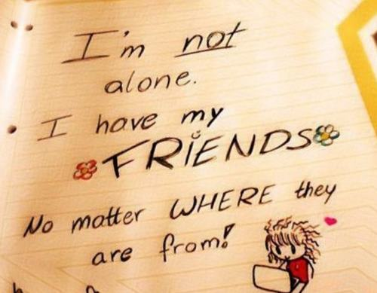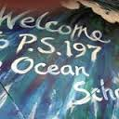1

**Reading Into-Reading**

The fifth grade will begin working on Tackling Complexity: Moving Up Levels of Nonfiction. Students will be identifying text features and text structures in nonfiction texts. In writing students will be writing a research report through the lens of American History. Students will be immersed in reading and writing informational texts. Please have students read in their “just right books” or online whenever possible.

**Math**

Our mathematicians are working on adding and subtracting fractions with like denominators. Scholars will continue focusing on the concepts of fractions. They will practice multiplication and division facts in school and should continue at home nightly. Fact fluency becomes increasingly important as multiplication and division concepts continue to grow. We are using Envisions in conjunction with KEMS as our primary math program. Both of these programs encourage the students to think differently and show as well as explain multiple ways of solving real-life word problems. KEMS focuses on developing a deeper understanding of the content, using strategies that foster understanding for students in algebra Please make sure your child knows his or her times table

**Social Studies**

Students will develop comparative case studies of Western Hemisphere Cultures. Countries such as the United States, Canada, Mexico, Caribbean, and South American countries will be researched. Scholars will focus on culture, geography, government, and economics.

**Science**

In Science, we will be identifying types of matter and the particles that make it up. Students will develop a model to describe that matter is made of particles too small to be seen.  We will be changing matter by melting, evaporating, and dissolving to prove that although the physical appearance has changed, the same amount of matter still exists.

Getting to the Core

of Success!

School begins at 8:20

Dismissal is at 2:40



Grade 5

Newsletter December 2021

Important Dates to Remember

Scholars are working on standard based activities. They are working on theme, main idea, character traits and inferencing.

ELA

Students are exploring the geography of New York and the specific landforms that make our state unique.

* Columbus Day – Oct. 12th

(schools closed)

* Parent Engagement is conducted daily from 2:10-2:30.
* Be sure to fill out the health screening daily when/if your child will be in the school building.
* Wear a Mask daily

Important to Remember

Curriculum

Students are Identifying Place Value, Addition, and Subtraction to One Million using multiple strategies to attain the correct solution.

Reminder:

**Winter Recess, School Closed**

**December 24, 2021 – January 2, 2022**

**Return to school on January 3, 2022.**

**Please make sure your child completes his or her Reading and Math packet over the vacation.**

The 5th Grade Team

Mrs. Binns

Ms. Blackett

Ms. Fong

**PBIS- Friendship**

**December’s PBIS word is Empathy.**

**Please hold your scholar accountable at home by showing ways they can connect with others through Empathy.**

Attendance:

Friendship

**Attendance continues to be a focus here at The Ocean School. Students are expected to report to school prepared to begin their day at 8:20 a.m. and be picked up at 2:40 p.m. In order to keep our learning fun, the fifth-grade team has planned some exciting and educational in class activities.**