

**Third Grade Team**

**Mrs. Byck & Mrs. Saur**

**Mrs. Perlstein**

**Ms. Zapata**



**Math**

In math, students use the S.O.L.V.E. method to help student’s break down one and two step word problems. Please make sure your child is constantly reviewing and practicing multiplication, rounding, addition and subtraction.

Building on our knowledge of arrays and equal groups, we are exploring the properties of multiplication. Specifically, we are modeling the commutative, associative and distributive properties. This will help us as we analyze patterns in multiplication, as well.

The math curriculum builds upon itself throughout the year. It is critical that students have a strong foundation. Please remind students to practice their basic math skills. Thanks for all your support!!

.

**Writing**

Our writers are putting the finishing touches on their small moment narratives in our “Crafting True Stories” writing unit. The scholars are learning to edit their true stories through the use of child-friendly checklists and rubrics.

Our next unit is a fan favorite. Students love our “Changing the World: Persuasive Speeches, Petitions and Editorials” unit in which they will have the opportunity to persuade people of their opinions. It is always an exciting unit, BUT be prepared to be convinced!



**Third Grade**

**Newsletter**

**November 2021**

**Reading**

At this time all students have been assessed and are aware of their reading levels. Please have conversations with your child about his or her reading progress and reading level (see below).

Students continue to build stamina in reading. Reading to someone is the best way to develop fluency! At this point in third grade, the expectation for independent reading time is a minimum of 20 minutes. Feel free to read more!

Readers continue to discover new plots, themes, and adventures with the characters in our Into Reading text. We are practicing making inferences, drawing conclusions about characters, differentiating between points of view, and figuring out the author’s purpose.

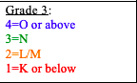

**Social Studies**

Our Social Studies unit is Geography and Culture. We will be taking a closer look at our community and others around the world. We’re practicing note taking and comparing the pros and cons of each place, including what factors impact each region.



**PBIS - Responsibility**

Our word of the month is responsibility. Ask your child how he or she is responsible in school and at home. How can being responsible help you when you are older?

**Friendly Reminders**

*School begins at 8:20 am and dismissal is at 2:40 pm

*Students must wear masks while on school property. Please remind your child of the importance of social distancing and mask wearing.

*”Saturday Academy” and “After School Program” are excellent opportunities to support your child’s educational needs. Please sign up for the programs.

**Science**

As we advance in the Force and Motion unit, students will explain what causes a train to start and stop moving as it rises, floats, and falls back to the tracks. We will do experiments with safety being our first priority. We will compare touching and non-touching forces. There will be lots of fun activities to explore magnets and gravity.

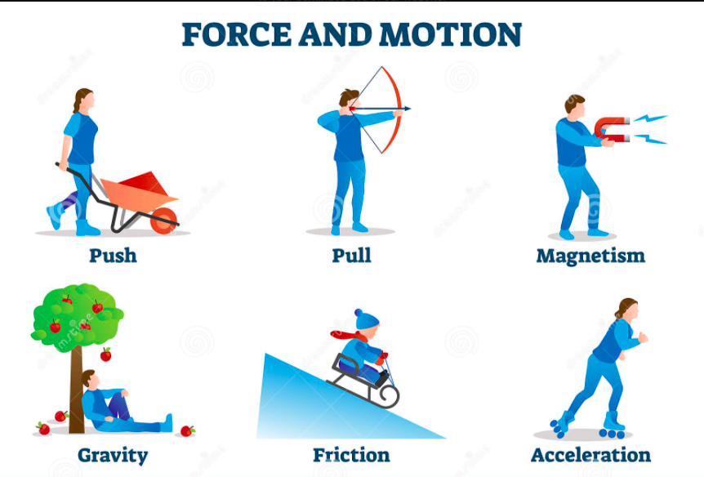

**Upcoming Events**

Election Day: Asynchronous Instruction 11/2

Parent-Teacher Conferences: Early Dismissal 11/4

**Holidays – No School**

Veteran’s Day 11/11

Thanksgiving recess 11/25 & 11/26

*Due to safety concerns, Crocs are not considered appropriate footwear for school.*