+

**Grade 4** Welcome back, we hope you and your family had a great holiday!

Scholars will be working on dividing whole numbers, as well as generating equivalent fractions. Additionally, they will be exposed to comparing and adding and subtracting fractions with like denominators.

Math

Scholars are working on standard based activities. They are working on theme, main idea, character traits and inferencing.

ELA

Students are exploring the geography of New York and the specific landforms that make our state unique.

* Columbus Day – Oct. 12th

(schools closed)

* Parent Engagement is conducted daily from 2:10-2:30.
* Be sure to fill out the health screening daily when/if your child will be in the school building.
* Wear a Mask daily

Important to Remember

Newsletter

Curriculum

Students are Identifying Place Value, Addition, and Subtraction to One Million using multiple strategies to attain the correct solution.

January 2022

*Wear a mask when coming to the school building and keep socially distanced from others

*P.S. 197Q is a uniform school. Students are to wear complete uniform daily with closed shoes.

*It is imperative that you encourage completion and assist your child with their daily Reading, Writing and Math homework to reinforce skills taught during the day.

Students will build their knowledge about art and creative talents, with a focus on the biography genre. We will read texts and view videos about how far your talents can take you. Ask about the texts your child is reading and what he/she has learned from them. Vocabulary focus: *sculpture*, *creativity, inspiration,* and *expressive.* Reinforce the topic by asking questions like *what gives you inspiration, and why?*

ELA

Scholars will explore Native American contributions to New York and America in categories such as: food, government, building and construction, the English language, NY landscape and names etc.

Social Studies

Science

 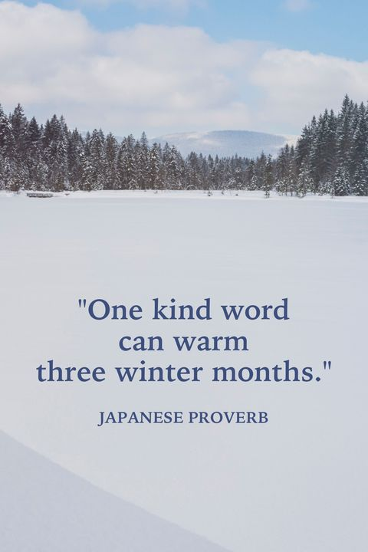

Writing

+

## P.S. 197 The Ocean School

## Instructional Focus

Scholars will focus on writing persuasive essays based on literary characters. They will apply the techniques they learned in opinion writing to enhance their literary writing skills in which, they will create a thesis statement and supporting it with examples and reasons from the text.

We are continuing our investigation and learning about electricity and magnetism through hands on experiments and making real life connections. Encourage our scholars to share and have open discussions at home about conductors, insulators, circuits, and static electricity to promote dialogue about what they are learning.

January 17th – School Closed (Martin Luther King Jr. Day)

February 1st – School Closed (Lunar New Year)

* School begins at 8:20 am

Dismissal is at 2:40pm

* Online Reading Sites: *MyOn.com, Readingeggs.com*
* Office Hours are every Tuesday from 2:40pm -3:55pm

Important Information

The 4th Grade Team:

Ms. Mangaru, Ms. Gelbart, Mr. Duncan, Ms. Perlstein, Ms. Fong, Ms. Zapata, Ms. Kaplan, & Mr. Acosta

PBIS- Cooperation

January’s PBIS word of the month is *Cooperation*. Please hold your scholar accountable at home by showing ways they can cooperate and by asking questions such as: Why is it important to cooperate? How is cooperation important for building positive relationships?

P.S. 197Q's Instructional focus for the 2021-2022 school year.

If we continue to engage our scholars and everyday writing, embed academic vocabulary along with rich discussions through the Advanced Literacy’s Approach and the Culturally Relevant Sustaining Education Framework. Then our scholars will receive rigorous writing instruction and engagement through all content areas.