The 3K Times

Important Dates
January 2nd - Welcome Back (Schools are open)
January 17th - Dr. Martin Luther King Jr. Day (Schools closed)

Unit of Study: Exploration Two:
Our Environment
Month Two: Investigating
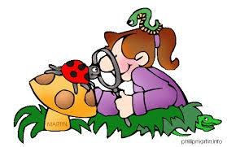
Happy New Year! We hope you enjoyed the holiday season and are excited to continue our exploration and learning!

This month in our Exploration, we will encourage children to build on their observations and to think critically about the things around them. We will move from highlighting what children see, to encouraging them to investigate and learn more about these things. They will have the opportunity to explore and study the environment around them. Children will show growth in their ability to make observations, analyze
results, draw conclusions and communicate results.
To help support our Exploration, encourage your child to learn more about the things that interest him/her. Provide resources such as books, videos, and hands-on experiences to spark their inquires and to gain more knowledge. Please review and use the key vocabulary words below to build background knowledge and to help your child understand the major inquiries of this Exploration.

Key Vocabulary
describe, detective, idea, materials, predict, record, research, share, suspect, think, thoughts, tools
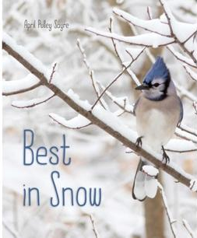
Suggested Books:
Best in Snow by April Pulley Sayre

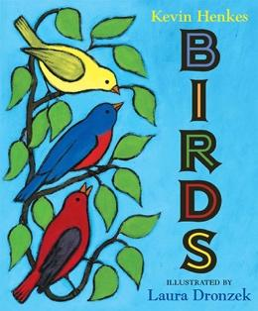
Birds by Kevin Henkes

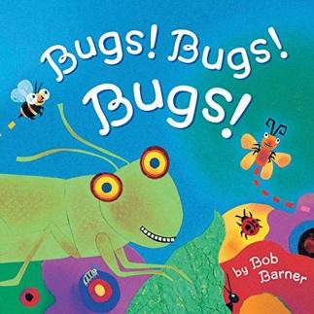
Bugs! Bugs! Bugs! by Bob Barner

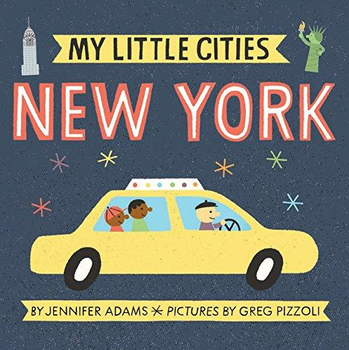
My Little Cities: New York by Jennifer Adams

Home Connection/Parent Engagement:
Look for signs in the environment. Draw or take pictures of some of the signs that are especially meaningful to your child.

Have your child look outside and talk about a few things that they
see and then make a list or draw pictures of these objects (i.e. I see birds flying in the sky). Children can bring these pictures back to school and we will create a class book.

Please
- label all clothing items that come to school including jackets, hats, gloves, etc.
- don’t forget to send in a fitted sheet and blanket for your child’s daily nap time.
- help your child become more independent putting on and zippering his/her jacket, packing and unpacking his/her school bag and toileting.

