

* *“Try to be a rainbow in someone else’s cloud.” –Maya Angelou*

### *— Malcom X​*

**Third Grade Team**

**Ms. Patron**

**Mrs. Perlstein**

**Ms. Saur**

**Mr. Seeger**

**Ms. Zapata**

**Reading**

Phonics is part of everyday instruction as we analyze data and identify areas of need. We will be increasing fluency and improving spelling by incorporating word building activities. The better we decode, the better we will be able to read, comprehend and analyze grade-level texts.

In March, we will be investing time in reading and analyzing a variety of grade-level texts. We have been practicing annotating texts that we independently read so that new words, important details and key events are highlighted. Referring to the text is essential when choosing the best answer to multiple-choice questions and developing open-ended responses.

**Third Grade**

**Newsletter**

**March 2022**

**Math**

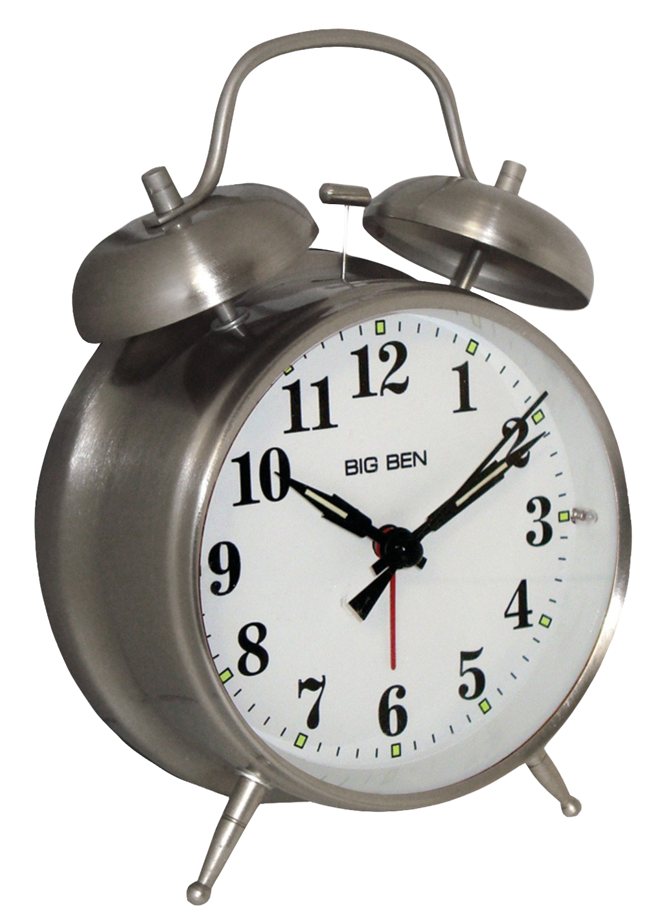

It’s ‘time’ to calculate elapsed time to solve problems of real-life situations. If I know it takes me a half hour to get dressed and eat breakfast and ten minutes to walk to school, what time should I wake up to be in school by 8:15? When analyzing problems such as this one, we draw on the various math strategies and operations to help solve them.

After working with time, we transition to other topics in measurement, including estimating volume and mass.

The S.O.L.V.E. strategy is consistently used to deconstruct word problems by creating an appropriate plan and using that plan to solve a given math problem.

\

.

**Writing**

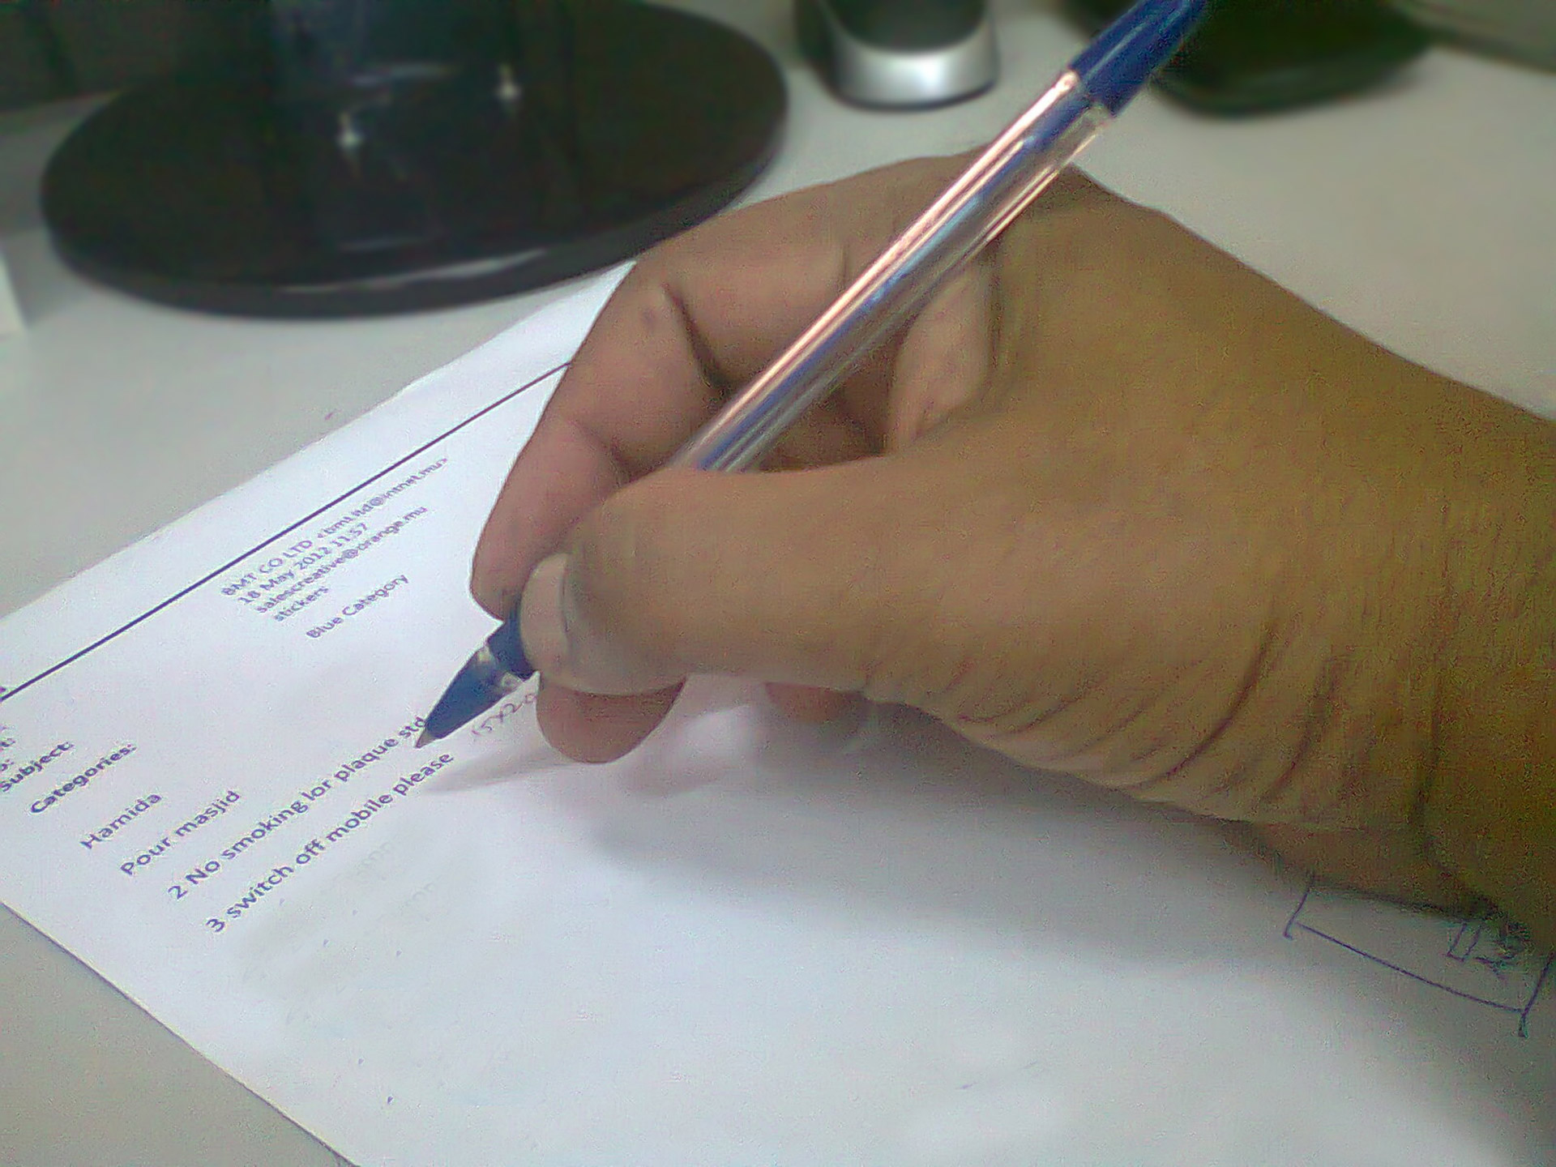

After publishing our information writing pieces, we embrace our next writing unit, response to literature. This will include, but will not be limited to, developing both short and extended responses to grade-level passages. Using text evidence is essential as we support our reasoning with direct quotes from the diverse genre that we read. We will become familiar with common sentence starters that will be used to when referencing the text.

**Social Studies**



As we continue to ‘travel’ though Nigeria, we will meet a Nigerian leader by reading, analyzing and responding to a non-fiction article describing his culture, responsibilities and goals.

Celebrate the women who have inspired and continue to inspire us! This month we will research and take note of the accomplishments of diverse females.

**PBIS – On Task**



Both children and adults stay on task to accomplish their goals. Focusing on what needs to be done is the first step in fulfilling our responsibilities in school, at home and in the community. In March, we focus on staying on task. Did you know that taking a brain-break can be an effective strategy for staying on task? We will role play and share tips for staying on task.

**Social Emotional Learning**

Each school day includes some time devoted to optimistic thinking. We use peer discussions to encourage positivity, build resilience and express gratitude.

**Important Events and Dates**

* March 3

*Student-Led Parent Teacher Conferences*

* March 29-March 30

*NYS ELA Exam*

**Science**

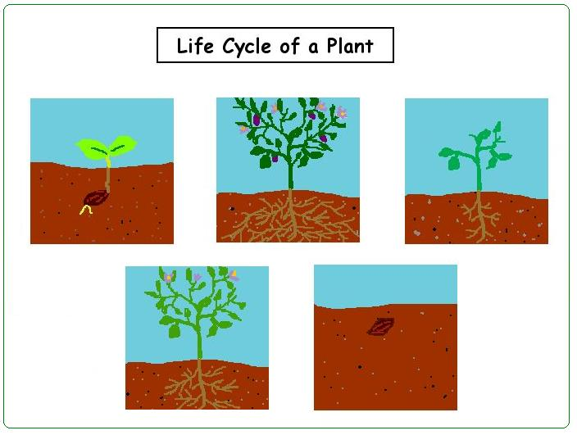

The beginning of spring is the perfect time to learn about the next topic in our Inheritance and Traits unit, the life cycle of the plant. We will identify and compare plant structures, as well. Each part of the plant has a specific function and we will use non-fiction resources to research them and explain their importance. Watch our knowledge grow!

***Important Message for Families***

***Greetings PS 197 Community:***

***Please remember to fill out your school survey before MARCH 24, 2022. Your participation is vital to our school.  Families will need to complete a separate survey for each child who attends our school.***

***Families can take the survey online via computer or mobile device at NYCSchoolSurvey.org in any of the ten DOE-supported languages. Just click on “parent/guardian survey”.***

***The access code is your child’s 9-digit OSIS# preceded by the letter “f”.  For example, if your child’s OSIS# is 123456789, then the access code is “f123456789”. Thank you for your attention to this matter.***

.