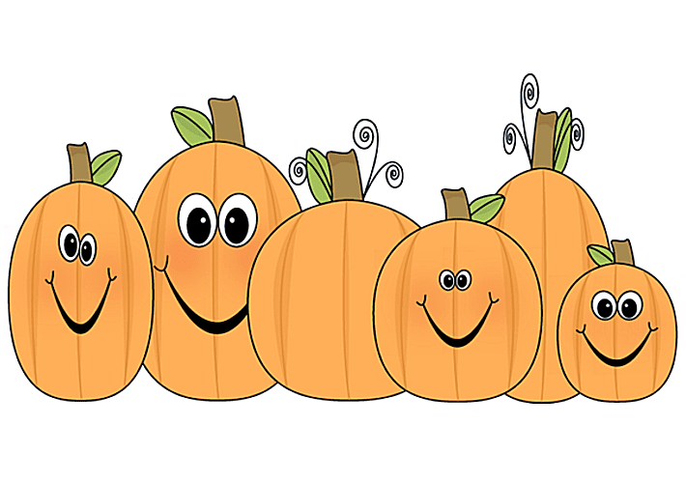
Pre-K Newsletter

October 2021

This Photo by Unknown Author is licensed under CC BY-SA-NC
Dear parents:
We are truly delighted to have your little ones with us! The children are adapting to Pre-k quite smoothly, and have started to develop friendships with classmates, and teachers. It is heart- warming to see how they begin to bloom and grow.
We would like to thank you for all the efforts you are making to bring your children to school on time every day, as well as your cooperation with all the COVID-19 related measures we must follow to stay safe.
The month of October will be exciting for the children, as we embark on unit 2 “My Five Senses”.

Home Connections/Parent Engagement
Invite your child to explore our five senses while on trips to the supermarket, restaurants, parks and other places of interest.
Discuss each experience and encourage your child to express his observations by making a drawing.
We will be sending Family Engagement Activities every Monday and we encourage you to complete and send back to share with the class. Kids love to share!
Important dates:
School will be closed on:
Monday October 11th for Italian Heritage Day/Indigenous People’s Day.
Friday October 15th
Hispanic Heritage assembly in the
School auditorium. (Dual Language Pre-k).
Unit 2: My Five Senses
We are excited to begin our unit: My Five Senses. Pre-K children naturally use their senses to explore the world around them. In our class, your child will have the opportunity to develop a wide variety of skills by using his/her senses in hands on learning and play. In this unit we are working on developing children’s abilities to take in information about the world through sight, hearing, smell, taste and touch.
We also use our senses to stay safe and will be talking about this throughout the study. We will learn about being careful and remembering not to touch sharp objects, things that are hot or things that are very dirty and might make us sick. You can help with this! Ask your child about some of the things outside of school or at home that are too dangerous to touch. How do we use our senses of sight, smell and hearing to stay safe?
Activities will focus on the following questions:
Week 1: How do we use our sense of sight?
Week 2: How do we use our sense of hearing?
Week 3: How do we use our sense of taste and smell?
Week 4: How do we use our sense of touch?
Vocabulary: autumn, blind, Braille, eyes, eyesight, fall, foliage, see, senses, view, vision, flavor, mouth, nose, savory, smell, sour, sweet, taste, taste buds, tongue
crunch, deaf, ears, hear, hearing aid, listen, loud, predictions, quiet, sign language, sound, volume,

