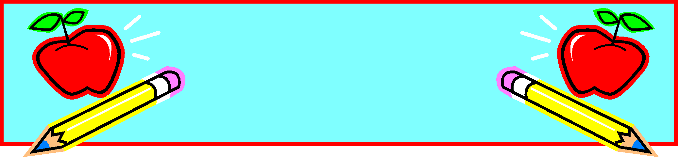

The Common Core State Standards, state that second graders should be reading on a level K or L at this time during the school year.

In Module 7 in our Into Reading curriculum, children will read and listen to stories about important people. These stories will help children recognize that people’s lives are shaped and molded by their experiences. Children will learn that every person has a story—and it may be a very fascinating one. In many cases, the stories in this module may describe events that are very similar to the experiences that the children have had. Children may be inspired after reading how closely the story of a very important person resembles their own!

In writing we will conclude our informational writing unit and we will begin our “From Scenes to Series” unit, where scholars will write realistic fiction stories. Encourage your child to use descriptive words when writing sentences.

In Fundations we will be working on Unit 11. This unit will focus on the long e sound. We will introduce various spellings of /e/ such as ee in jeep, ea in eat, and ey in key. We will also review previously taught concepts such as closed syllables, glued sounds, and vowel-consonant-e syllable types. Encourage your child to read every day and identify various syllable types.

**Friendly Reminders**

* ***Greetings PS 197 Community:***
* ***Please remember to fill out your school survey before MARCH 24, 2022. Your participation is vital to our school.  Families will need to complete a separate survey for each child who attends our school.***
* ***Families can take the survey online via computer or mobile device at NYCSchoolSurvey.org in any of the ten DOE-supported languages. Just click on “parent/guardian survey”.***
* ***The access code is your child’s 9-digit OSIS# preceded by the letter “f”.  For example, if your child’s OSIS# is 123456789, then the access code is “f123456789”.***

# 

* **Thursday, March 3rd – Parent-teacher conferences in the afternoon and evening**

**PBIS**

The PBIS word for March is “On Task.” We will teach our scholars ways to be prepared and focused at school. Students can show being "On Task" by demonstrating the ability to stay focused and completing their work. Show your child different ways to stay "On Task" when at home.

**Technology**

We are continuously infusing various forms of technology into our lessons. Students read books on Raz-kids, MyOn, and Epic books. Students are also using Reading Eggs to increase their reading skills. Please remember to send in a pair of headphones for your scholar. Please make sure your child brings their iPad to school fully charged every day. They can also log into the various reading apps at home.

**Social Studies & Science**

Our new science unit, “Properties of Materials,” entails answering the question: “How can you design a mixture for a certain purpose?” For centuries, humans have undertaken this challenge. From the creation of medicines, paints, and building materials, to the development of cleaning products, adhesives, and foods, mixtures have proven to be essential to life as we know it. By mixing ingredients together, it’s possible to create a mixture that takes on some of the properties of its ingredients. In this unit, our scholars will take on the role of glue engineers and use engineering design practices to create a glue for use at home or at school, which serves as the design problem for the unit.

In social studies we will begin a new unit of study entitled, Urban, suburban and Rural Communities. Our focus will be how are communities the same and how they are different. Students will be taking a closer look at the features in the community. Students will also examine how natural resources shape the way a community develops.

This month we will begin Topic 9 in our math curriculum. In this topic, Numbers to 1,000, students’ understanding of place value is extended to 1,000. This understanding serves as a foundation for adding and subtracting within 1,000.

**English Language Arts**

**Ms. Bambach, Ms. Browne, Ms. Lopez, Ms. Taylor and Mr. Seeger**

**“The more that you read, the more things you will know. The more that you learn, the more places you’ll go.”**

**-Dr. Seuss**

**Mathematics**

PS 197 Q

The Ocean School

Far Rockaway,

New York

*SECOND GRADE*

*March 2022*

PS 197 Q

The Ocean School

Far Rockaway,

New York

***Second Grade***

***January 2021***