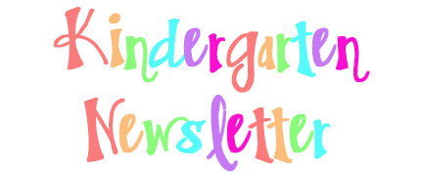
A Note from The Kindergarten Teachers:  Happy Thanksgiving! We are very thankful for the opportunity to teach the scholars at P.S. 197. The word of the month for November is “Responsibility”. We will focus on the importance of being responsible at school and at home. Two books that we will use to discuss responsibility are:  Lilly’s Purple Plastic Purse by Kevin Henkes  Pigeon Wants a Puppy! by Mo Willems. | Fundations:  Please review the following letters at home:  t,b,f,n,m,I,u,c,o,a,g,d,s  During the month of November, our scholars will be learning new letter sounds, finding letter sounds using our magnetic boards and will practice writing new letters. They will also learn that every sentence and their names begin with a capital letter.  Some helpful websites are: starfall.com and Have Fun Teaching
Math:  During the month of November, the students will practice counting, writing and representing the numbers 6-10. The scholars will also continue to practice problem solving skills. They will identify the problem and explain their answers using objects, pictures and numbers.  Some helpful websites are: splash math, starfall.com, and abcya | Reading:  In Module 2 “There’s Only One Me” the students will learn from the characters in the stories. They see that when we take time to appreciate who we are- inside and out, our successes and shortcomings-the happier we are to just be ourselves. And the better equipped to celebrate our differences. The students will also learn to identify the characters, setting and events in the story.  Writing:  We will introduce Unit 2 of our Writing Workshop: “Show and Tell”. Our scholars will study objects such as leaves, pinecones, and pumpkins. Our scholars will learn how to use adjectives to describe these objects.
Reminders:  - Please remember to write your child’s name on their lunch bags, jackets and sweaters.  School Closed - The following Days  - Tuesday - 11/2 Election Day-Election Day, fully remote, asynchronous instructional day  - Thursday - 11/11 Veteran’s Day  - Parent Conferences  - Thursday and Friday- 11/25 and 11/26 Thanksgiving | Science:  In Science, students take on the role of scientists in order to figure out why no monarch caterpillars live in the area that was converted from a field to a community vegetable garden. They investigate how plants and animals get what they need to live and grow, and then they make a new plan for the garden that will provide for the needs of monarch caterpillars and produce vegetables for humans.
Social Studies:
In Social Studies, students will continue to discuss what it means to be a member of a community. Students will discuss the importance of the rules we follow in school and in our community. They will also learn about community helpers and their roles/responsibilities.

