We are so excited to begin our unit on Transportation this month! Our scholars will be exploring many different modes of transportation and their importance. The students will compare and contrast different modes of transportation. We will also explore how vehicles move and learn about the workers that operate the vehicles in our community. The children will discuss safety and traffic rules that protect us when using any kind of transportation. We are excited to begin this unit after our winter break.

Key Vocabulary: accident, airplane, airport, bicycle, bridge, bus, car, conductor, crossing guard, emergency, engine, ferry, fire engine, helicopter, helmet, keys, license plate, local, mail carrier, mechanic, operator, pilot, police, safety, scooter, school bus, seatbelt, speed, light traffic, train

# We would like to wish our wonderful families happiness this holiday season. Our scholars are working hard to learn letters/sounds, recognize numbers and count with one-to-one correspondence up to 20. In the month of December, we were busy learning about the different homes in their community. We discussed homes for people and habitats for different animals. We spent some time learning about different celebrations and similarities and differences in the home life of families. Students shared how they celebrate the holidays in their homes. The students also engaged in the holiday spirit by creating holidays crafts.



### Unit 4:

### Transportation

##### January 17th

*January 2021*

**Pre-K Newsletter**

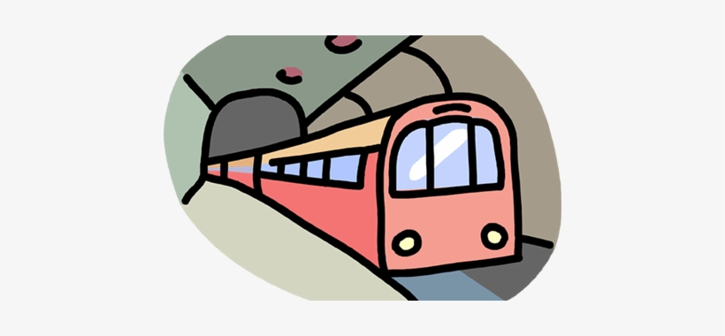

#### Transportation

Home Connections/ Parent Engagement

Take a community walk or drive with your child and encourage him/her to notice all the different vehicles in the community. Ask your child what he/she thinks each vehicles’ function is, such as a school bus or city bus and further their thinking by asking why we need these vehicles in our community. After you come home, encourage your child to draw a picture of the vehicles he/she saw on the walk.

#### Save the Date!

##### December 24th -

##### January 3rd

School closed-

Winter Break

School closed- Martin Luther King Day