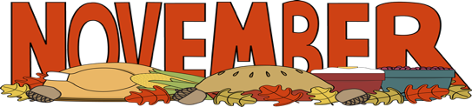
The 3K Times
Important Dates
Election Day – November 2 – Remote Learning for all students
Parent Teacher Conference (Afternoon)- November
Parent Teacher Conference (Evening)- November
Veterans Day – November 11 - School is Closed
Thanksgiving – November 25 & 26 – School is Closed

Unit of Study: Our Community
Focus Area: Us
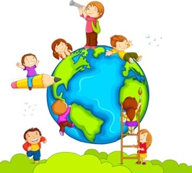
In this unit of study, your child will have the opportunity to continue to explore who they are as well as their surroundings.
Students will continue to explore all the learning centers, classroom resources such as toys, puzzles, art supplies as well as the routines of the classroom.
This month in our Exploration, we will have the opportunity to learn about and connect with the other children in the class. Throughout the Exploration, children are learning what it means to be together with friends and family as well as to be apart. Children will have the opportunity to explore their emerging sense of belonging. They will show growth in their understanding of their personal connections with others.

Home Connection/Parent Engagement:

- Discuss with your child the different members of their family.
- To help support our Exploration, you can ask your child about the other children in our 3-K classroom and what they like to do together. Inquire about activities your child likes to do with others.

- Go on a neighborhood walk and observe changes to the environment and collect items such as leaves, acorns, pinecones, etc. Bring them into school!
- Cut open a pumpkin and have your child explore touching the flesh, counting and sorting the seeds. Try making pumpkin soup or pumpkin bread. Also roast the seeds for a delicious and nutritious snack.

Learning Experiences:
- Students will explore the art center and use various materials to create self and family portraits.
- Students will use art to recognize and express theirs and others’ emotions.
- In science, students will use tools to examine autumn-related items such as acorns and pinecones.
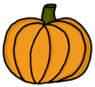
- Students will describe characteristics of people and animals

Reminders:
- Please remember to dress your child in the school’s uniform and appropriate shoes (no crocs)
- Please check your child’s folder every night.
- Please replace extra clothes to leave in the classroom when your child has had an accident. Also send in diapers/ pull ups if your child is not yet potty trained.

