# 3-K Newsletter

**Exploration Topic**: Our Community

**Essential Question**: What is our community?

**Focus Area**: Self

Dear Families,

It has been exciting to get to know the children in our 3-K class as they have been learning more about our classroom, our routines, and our transitions. Thank you for supporting us in creating a safe, predictable, and stable environment for your child.

This month in our Exploration, students will get to familiarize themselves with all of the centers in the classroom and consider their preferences, interests and needs. The children will have the opportunity to explore their emerging sense of self. They will show growth in their understanding of personal characteristics, behaviors, likes and dislikes.

**Parent Engagement:**

To help support our Exploration, you can help your child discover more about him/herself. Discuss your child’s personal characteristics, likes and dislikes, favorites, feelings, and more. Inquire about your child’s interests and encourage your child to explore and develop in those areas of interests as well as introduce them to new things, ideas, and activities.

Please continue to encourage independence at home, review the routines and expectations in school, and review and use the key vocabulary words below to build background knowledge and to help your child understand the major inquiries of this Exploration.

We look forward to having a wonderful year filled with lots of fun and learning with your child.

Thank you!

Sincerely,

3-K Teachers

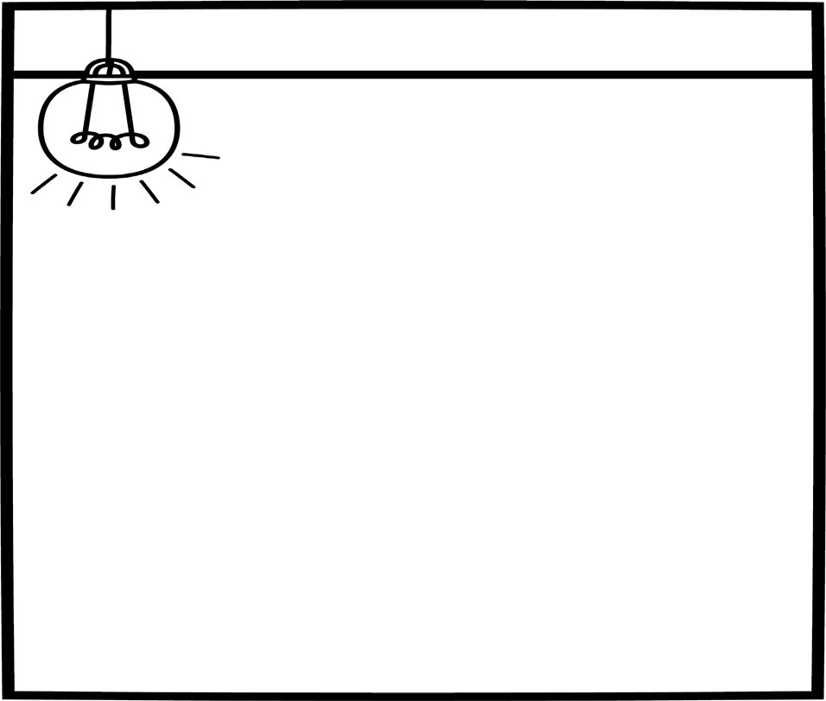

**DATES TO REMEMBER:**

October 11- No School

#### Key Vocabulary:

##### absent, apart, away, back, best, body, brave, calm, dislike, enjoy, excited, favorite, feel, frustrated, fun, happy, hug, like, love, mad, me, miss, notice, prefer, present, puzzle, reminds, sad, scared, see, upset, worst